Project Planning Phase
Project Planning Template (Product Backlog, Sprint Planning, Stories, Story points)
Date | 08 October 2026
Team ID | 9100SmartGirls
Project Name | Streamlining IT Procurement: Automating Standard Laptop Orders with Flow Designer
Maximum Marks | 5 Marks

Product Backlog, Sprint Schedule, and Estimation (4 Marks)
Use the below template to create product backlog and sprint schedule
Sprint | Functional Requirement (Epic) | User Story Number | User Story / Task | Story Points | Priority | Team Members
Sprint-1 | Requirement Analysis | USN-1 | As a member of the IT procurement team, I document the business use case and requirements so that the scope of the automation is clear. | 2 | High | [Member 2 Name]
Sprint-1 | Flow Creation | USN-2 | As an administrator, I create the flow "Standard Laptop Task" with Application Global and Run As System User. | 2 | High | [Team Lead Name]
Sprint-1 | Flow Creation | USN-3 | As an administrator, I add the Service Catalog trigger so that the flow starts when a laptop is ordered. | 1 | High | [Team Lead Name]
Sprint-1 | Task Automation | USN-4 | As a member of the IT procurement team, I want the Create Catalog Task action to set the Short Description, Description, Assignment Group (Hardware) and Approval so that the configuration task is created automatically. | 5 | High | [Team Lead Name]
Sprint-2 | Flow Creation | USN-5 | As an administrator, I save and activate the flow so that it runs when the trigger conditions are met. | 1 | High | [Team Lead Name]
Sprint-2 | Flow Assignment | USN-6 | As an administrator, I attach the flow to the Standard Laptop item through Maintain Items and Process Engine. | 3 | High | [Member 3 Name]
Sprint-2 | Service Catalog | USN-7 | As a user, I can order a Standard Laptop from the Hardware category of the Service Catalog using Order Now. | 2 | High | [Member 4 Name]
Sprint-2 | Service Catalog | USN-8 | As an approver, I approve the laptop request from the Approvers section. | 2 | Medium | [Member 4 Name]
Sprint-2 | Service Catalog | USN-9 | As a member of the hardware team, I receive the configuration catalog task under the Requested Item. | 2 | High | [Member 3 Name]
Sprint-3 | Testing & Validation | USN-10 | As a tester, I execute the functional and performance tests of the flow. | 3 | High | [Member 5 Name]
Sprint-3 | Testing & Validation | USN-11 | As a tester, I run user acceptance testing and track bugs. | 2 | Medium | [Member 5 Name]
Sprint-3 | Documentation | USN-12 | As a team, we prepare the project documentation and final report and conclude the project. | 5 | Medium | All team members

Project Tracker, Velocity & Burndown Chart: (4 Marks)
Sprint | Total Story Points | Duration | Sprint Start Date | Sprint End Date (Planned) | Story Points Completed (as on Planned End Date) | Sprint Release Date (Actual)
Sprint-1 | 10 | 6 Days | [START DATE] | [END DATE] | 10 | [RELEASE DATE]
Sprint-2 | 10 | 6 Days | [START DATE] | [END DATE] | 10 | [RELEASE DATE]
Sprint-3 | 10 | 6 Days | [START DATE] | [END DATE] | 10 | [RELEASE DATE]

Velocity:
The sprint duration is 6 days and each sprint delivers 10 story points. Total story points = 10 + 10 + 10 = 30 across 3 sprints.
Average Velocity (AV) = Total story points completed / Number of sprints = 30 / 3 = 10 story points per sprint.
Velocity per day = Sprint velocity / Sprint duration = 10 / 6 ≈ 1.67 story points per day.
Burndown Chart:
A burndown chart is a graphical representation of work left to do versus time. The chart below shows the story points remaining for the project over the 18 working days of the three sprints, compared with the ideal burndown line.
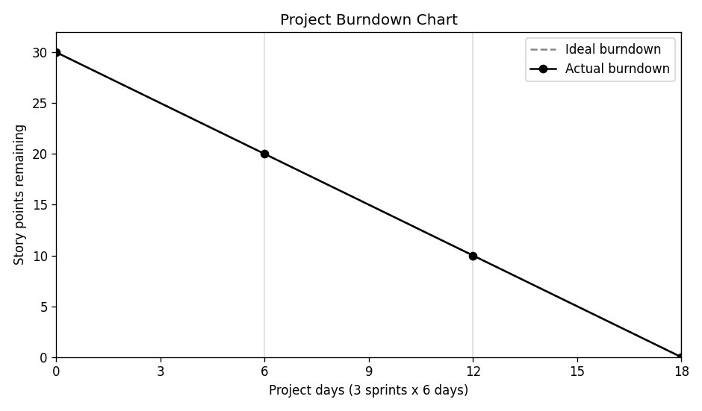
Reference:
https://www.atlassian.com/agile/project-management
https://www.atlassian.com/agile/tutorials/epics
https://www.atlassian.com/agile/tutorials/sprints
https://www.atlassian.com/agile/project-management/estimation
https://www.atlassian.com/agile/tutorials/burndown-charts

